Title   
Subtitle

*Author name 11, Author name 22* **(leave this blank for review)**

Affiliation, country, author’s e-mail address 2 Affiliation, country, author’s e-mail address

**Keywords:** 3-5 keywords

**Abstract**

This document presents the instructions needed to prepare the best practice papers to be included in the proceedings of the 6th International Conference on Architecture, Research, Health, and Care ARCH24. The papers will be published in the Aalto University series of publications. We kindly ask you to make your paper look exactly like the template document. The easiest way to do this is by replacing the content with your own material.

All papers should be written in English (British or American). It is expected that authors will submit carefully written and proofread material. We propose the best practice papers to be approximately 2000-3000 words, excluding references.

The first page should contain the paper’s title, the authors’ names, affiliations, emails, and countries. The paper structure is as follows: 1. Authors; 2. Keywords; 3. Abstract; 4. Text; 5. References (if applicable). The headers are non-editable. Images and tables should be centered on the page horizontally, as well as their respective captions, which should be placed under the images and above the tables.

**1. Layout, fonts and paragraph styles**

- Header: 1.7 cm

- Footer: 1 cm

- Margins (top, bottom, left, right): 2.5 cm

Text is not hyphenated; titles are aligned to the left, and the body text is justified with line and paragraph spacing of 1.5.

- Main title and subtitle: Arial 20, bold + Arial 16, bold (respectively)

- Author’s names: Arial 11, Italic

- Author’s information: Arial 8

- Keywords: Arial 11, bold (title) + Arial 11 (keywords)

- Titles/sections: Arial 11, bold

- Subtitles/subsections: Arial 11, bold

- Body text: Georgia 11

- Figures/captions/tables: Georgia 11, bold (titles) + Georgia 11 (text)

- References: Georgia 11, Italic (book/article titles) + Georgia 11

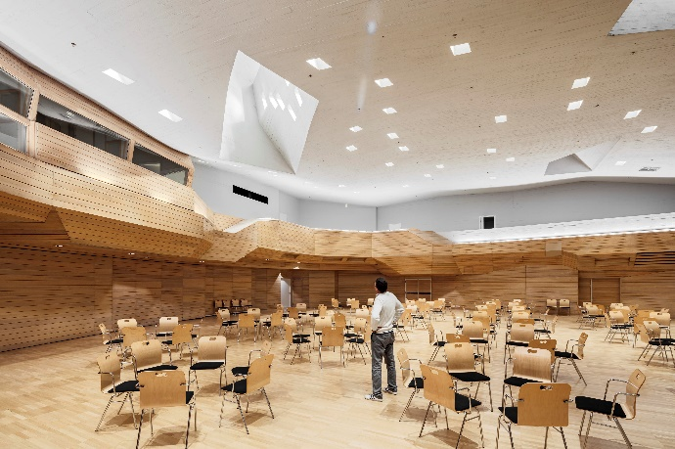

**Figure 1.** This is a figure

# 2. Section

Lorem ipsum dolor sit amet, consectetur adipiscing elit. Donec vulputate pulvinar semper. Donec malesuada sed ante feugiat ornare. Donec egestas mi a sem ultrices gravida. Donec viverra commodo consequat. Etiam ac purus malesuada, iaculis quam id, sollicitudin nulla. Nam purus dui, auctor id erat ut, venenatis molestie nisi. Integer eget elit ut mi sollicitudin elementum at quis dolor. Lorem ipsum dolor sit amet, consectetur adipiscing elit. Donec vulputate pulvinar semper. Donec malesuada sed ante feugiat ornare. Donec egestas mi a sem ultrices gravida. Donec viverra commodo consequat.

* bulleted list
* bulleted list

Lorem ipsum dolor sit amet, consectetur adipiscing elit. Donec vulputate pulvinar semper. Donec malesuada sed ante feugiat ornare. Donec egestas mi a sem ultrices gravida. Donec viverra commodo consequat. Etiam ac purus malesuada, iaculis quam id, sollicitudin nulla. Nam purus dui, auctor id erat ut, venenatis molestie nisi. Integer eget elit ut mi sollicitudin elementum at quis dolor.

**Table 1.** This is a table

|  |  |  |
| --- | --- | --- |
| **Title 1** | **Title 2** | **Title 3** |
| entry 1 | data | data |
| entry 2 | data | data |

## 2.1. Subsection

Lorem ipsum dolor sit amet, consectetur adipiscing elit. Donec vulputate pulvinar semper. Donec malesuada sed ante feugiat ornare. Donec egestas mi a sem ultrices gravida. Donec viverra commodo consequat. Etiam ac purus malesuada, iaculis quam id, sollicitudin nulla. Nam purus dui, auctor id erat ut, venenatis molestie nisi. Integer eget elit ut mi sollicitudin elementum at quis dolor.

## References (if applicable)

When used in the text, mention the author and date of birth in brackets as exemplified: (Author, 1995) or as Author (1993) wrote…

The list of references should be placed at the end of the paper in alphabetical order as exemplified:

Author, A. (1995), *Book Title*, Publisher Name, Publisher Location, 1995

Author, B. (1993), Article title, *Journal Title*, 66 (1993), p. 856–890